YEAR 1
Dear Year 1 parents and carers,
We have put together some online learning resources and an overview of what we are currently learning in school to help you continue with learning at home.
In Maths we are currently looking at weight and capacity. You could do many activities at home with your child such as baking and making potions using different amounts of coloured liquid (this requires food colouring). When you do this, take some photos and add them to the schools website scrapbook. I have also included some arithmetic sheets, which we do on a weekly basis (Friday). We usually go through some of the questions but then give the children 20-25 minutes silence (test-style) to try to work out the answer to the questions; they can answer these on the sheet.
In English we are currently reading the story ‘Lost and Found’ by Oliver Jeffers (you can find this story on YouTube). I have put together a small pack, which is enclosed within your home learning pack with different activities to do on different day’s right up to the Easter holidays. For Spellings, I will upload these weekly onto the school website section where you can self-mark and send me their result. To test, I usually say the word, put the word into a sentence and then repeat the word. Try not to help sound out the word.
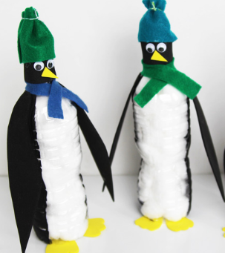
In Topic we are looking at ‘Why don’t penguins need to fly?’. Our half term homework was to create their own penguin using the following where possible (please use different equipment should you need to):
- 1 x plastic drinks bottle
- Black card
- Coloured felt
- Googly eyes
- Cotton wool
For Phonics, I have included lots of resources to help with phonics that we would usually teach on a daily basis (roughly 25-30 minutes each day). I have included three booklets that you can work through which cover all of the sounds the children need to know in order to pass their Year 1 phonics screening. Again, you can self-mark these.
We have also provided many online resources that you will find on the next page and our class page on the school website. Some of these you do need to sign up for but they all have a free option.
As always, If you have any questions please do not hesitate to ask.
Thanks,
The Year One Team.

Phonics:
- Phonics play: https://www.phonicsplay.co.uk/
- Teach your monster to read: https://www.teachyourmonstertoread.com/
- Mr Mc: https://www.mrmcmakingmemories.com/ - there are lots of resources on this website that are free to download. The flash cards and segmenting and blending powerpoints are very helpful.
- Phonics Bloom: https://www.phonicsbloom.com/
- http://www.oxfordphonicschecksupport.co.uk/ - this website allows you to create your own phonics screening tests. You can select the phases that you feel your child needs to improve on (Year one children are expected to pass phase 5).

Reading:
- https://www.oxfordowl.co.uk/ - you can sign up to this website for free and it allows you to read a selection of eBooks similar to the books your child would be reading at school.

Maths:
- Top marks: https://www.topmarks.co.uk/ - there are lots of interactive games that children can play of tablets and PC.
- https://www.bbc.co.uk/cbeebies/topics/numeracy
- https://www.bbc.co.uk/bitesize/subjects/zjxhfg8

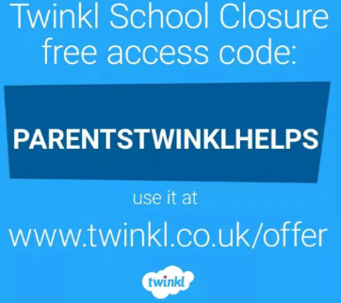
Twinkl:
- https://www.twinkl.co.uk/ - twinkl are providing lots of free online home packs for children which include literacy, numeracy and phonics. There is normally a subscription fee but they have a free month offer for parents if you sign up using the code PARENTSTWINKLHELPS.

