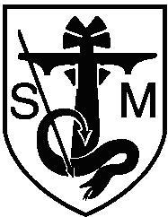
St Michael's C. of E. Primary School, Bamford
Bury & Rochdale Old Road
Heywood
OL10 4BB

Supplementary Form 2026 - Faith allegiance

Name of child _______________________________________________

Name of parent/carer _________________________________________

Address _________________________________________________

_________________________________________________

Place of regular worship ______________________________________

I confirm / do not confirm* a minimum of 30 weekly parent/carer attendances or 57%** weekly attendances for the named child with a parent/carer or grandparent in the year (week beginning Monday 11th November 2024 to Sunday 9th November 2025) before application at the above place of worship when the church is fully reopen.

*Delete as appropriate
**Should churches not be fully open, for admissions to Reception in September 2024 the definition of ‘regular worship and attendance’ is 30 out of 52 attendances or 57% attendance when church is fully reopen. This is calculated as the number of weeks attendance divided by the number of weeks church has been fully open x 100.

Signature _______________________________ (Minister of religion)

Title and name _______________________________

Signature _______________________________ (Parent/carer)

