St Michael’s C of E Primary School - Our Computing Vision

Our Aims for pupils are:

- To prepare our learners for their future by enabling them to gain knowledge and develop skills that will equip them for an ever-changing digital world.
- To learn skills in digital literacy, computer science, information technology and online safety to ensure that children become competent in safely using, as well as understanding, technology.
- To revisit strands repeatedly through a range of themes during the children’s time at St. Michael’s, ensuring that the learning is embedded and skills are successfully developed.
- To support St. Michael’s children’s creativity and cross-curricular learning to engage and enrich their experiences in school.
How?
Design
- We teach Computing through strands which are revisited regularly.
- The threads ensure that the skill is embedded and successfully developed.
- Children are encouraged to express themselves and develop their ideas. For example; personalising their programming designs, creating online drawings of their choice and presenting information using multimedia.
- Children are given access to a wide range of quality resources and cross-curricular opportunities are provided to allow children to apply their Computing knowledge and skills. For example, developing their skills of using the internet safely to research topics in foundation subjects.
- Online safety is taught at the beginning of every year group for the first two lessons to ensure children are equipped with the skills and knowledge to support them. All safety procedures are shared with staff. To make sure we have an impact, online safety is revisited regularly during computing lessons, and an online safety week ensures that children have exposure and reminders to staying safe online. Our online safety lessons and resources are created by Project EVOLVE. Below are the key units covered from Early Years to Year 6. Each unit is planned with care to make sure it is appropriate for the age group.
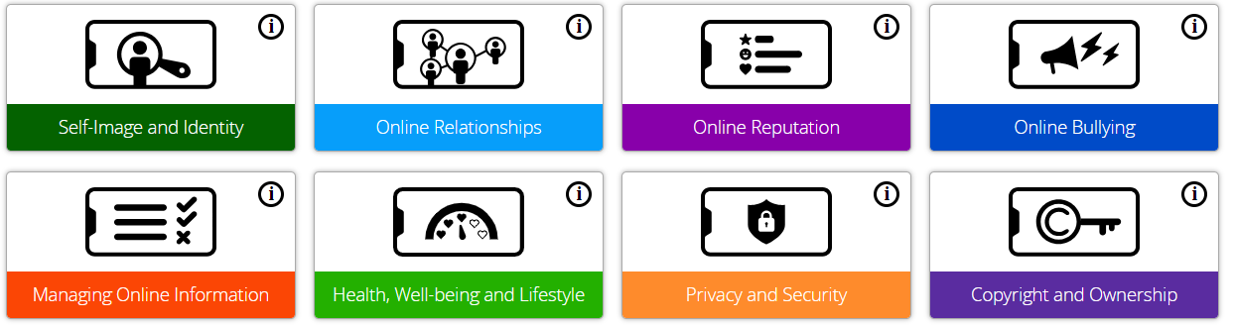

Teaching and Learning of computing
- Year group learning is split into 6 strands, 1 per half term.
- Children take part in plugged lessons and un-plugged lessons throughout a unit to encourage pupils to become computational thinkers.
- We share the big picture. This consists of explaining to the pupils the skills we will be focusing on and the sequence of learning we shall learn through to reach the ultimate goal.
- We strive to provide children with the latest resources and software so that teaching is current and up-to-date.
- SEND children are supported and adaptations made when necessary.
- Teachers use rich, engaging resources so that pupils value and enjoy their learning experiences.
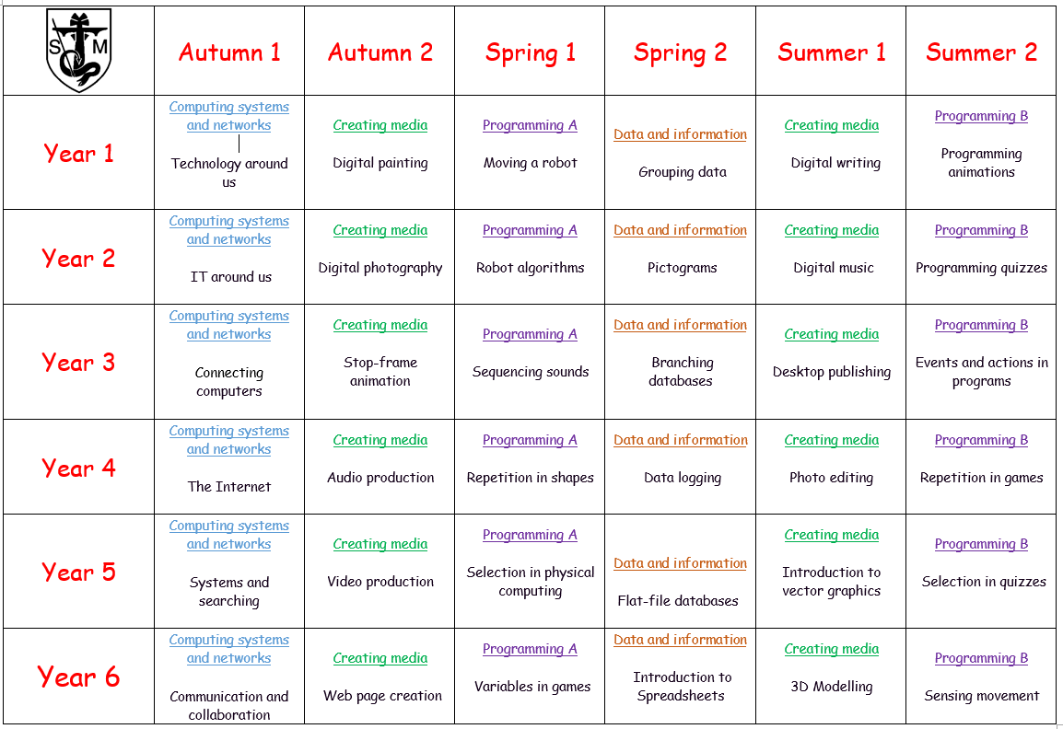
- There are no early learning goals that directly relate to computing objectives, though it is our expectation that children will be introduced to appropriate technology and use it within their provision.

Impact:
- All children who leave St. Michael’s are competent, safe, thoughtful users of ICT with an understanding of how the role of technology in modern life.
- They will have developed skills, knowledge and technical vocabulary to express themselves and be creative in using digital media.
- They will be equipped to apply their skills in Computing to different challenges going forward.
- They have high aspirations, which will see them through to further study, work and a successful adult life.

