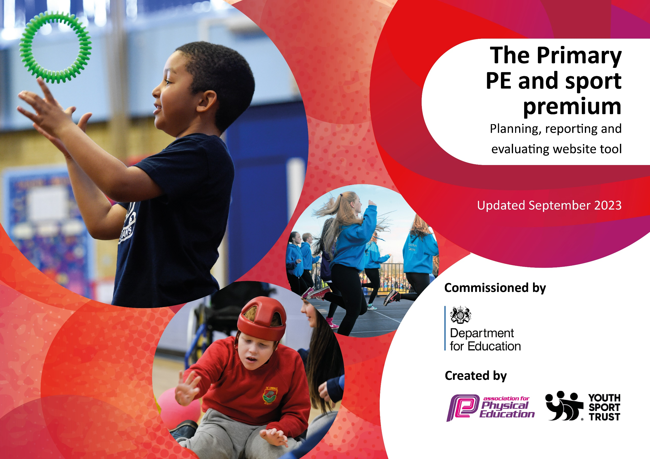

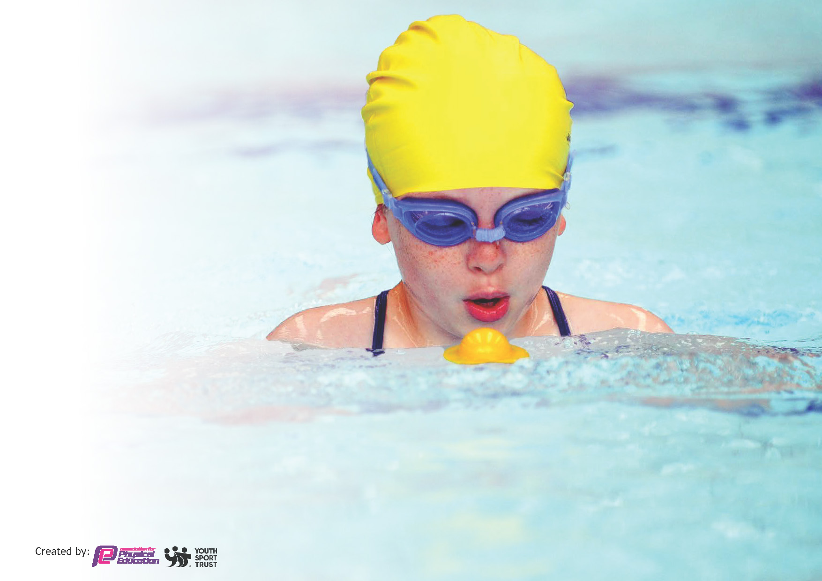
This template can be used for multiple purposes:
by:
- It enables schools to effectively plan their use of the Primary PE and sport premium
- It helps schools to meet the requirements (as set out in guidance) to publish information on their Primary PE and sport premium
- It will be an effective document to support Ofsted inspections enabling schools to evidence progress in Physical Education (PE) and evidence swimming attainment, which forms part of the PE National Curriculum. We would recommend schools consider
the Intent, Implementation and Impact of any spend, as examined within the Education Inspection Framework.

It is important that your grant is used effectively and based on school need.

Schools must use the funding to make additional and sustainable
improvements to the quality of the PE, School Sport and Physical Activity (PESSPA)
they offer. This means that you should use the Primary PE and sport premium to:

- Build capacity and capability within the school to ensure that improvements made now will benefit pupils joining the school in future years
- Develop or add to the PESSPA activities that your school already offers.

The Primary PE and sport premium should not be used to fund capital spend projects; the school’s core budget should fund these. Further detail on capital expenditure can be found in the updated Primary PE and sport premium guidance.

Key priorities and Planning
This planning template will allow schools to accurately plan their spending.

Action – what are you planning to do | Who does this action impact? | Key indicator to meet | Impacts and how sustainability will be achieved? | Cost linked to the action
Introduce lunchtime sport sessions/activities for pupils. | Year 6 children. They are completing the Playmaker Award.  KS1 and KS2 Pupils – as they will take part in activities run by the Play Leaders. | Key indicator 2 -The engagement of all pupils in regular physical activity. | More pupils meeting their daily physical activity goal, more pupils encouraged to take part in PE and Sport Activities. | £175 cost for the Play Maker training. £150 on equipment for the children to use to run the activities.
CPD for staff leading PE teaching.  Purchase of a skill based planning scheme.  Specialist PE coaches delivering Physical Education 1x per every two weeks to each class.  Specialist coaches to be booked to deliver ‘taster’ classes to all pupils/particular phases (depending on sport).  Facility hire, equipment purchase and hire for outdoor adventurous activities.  Membership Fee for Heywood Schools Sport Collaborative.  Purchasing equipment for PE and Sport.  Facility and instructor hire in Keswick for water activities.  Subsidise the cost of extra-curricular sport clubs. | Teaching Assistant Level 3.  All staff who deliver PE.  All children in the school.  All children in the school.  Children from Reception to Year 6.  Children from Years 1 – 6 will have opportunities to participate in competitive sport with other schools both in and out of curriculum time.  All children across school.  Year 6.  Children who are wanting to participate in any extra-curricular activities. | Key Indicator 1: Increased confidence, knowledge, and skills of staff in teaching PE and sport.  Key Indicator 1: Increased confidence, knowledge, and skills of staff in teaching PE and sport.  Key Indicator 2: Engagement of all children in regular physical activity. Key Indicator 5. Participation in competitive sport.  Key indicator 4: Broader experience of a range of sports and activities offered to all pupils. Key Indicator 3: The profile of PE and Sport is raised across the school.  Key indicator 4: Broader experience of a range of sports and activities offered to all pupils. Key Indicator 3: The profile of PE and Sport is raised across the school.  Key Indicator 5. Increased participation in competitive sport.  Key Indicator 5. Increased participation in competitive sport. Key Indicator 2: Engagement of all pupils in regular physical activity.  Key indicator 4: Broader experience of a range of sports and activities offered to all pupils.  Key indicator 4: Broader experience of a range of sports and activities offered to all pupils. Key Indicator 2: Engagement of all pupils in regular physical activity. | Primary teachers more confident to deliver effective PE.  Primary teachers/staff more confident to deliver effective PE for the year group expectations.  Children have access to specialist PE coaches. This will further enhance their confidence and ability when participating in competitive sporting events.  More pupils meeting their daily physical activity goal, more pupils encouraged to take part in PE and Sport Activities.  More pupils meeting their daily physical activity goal, more pupils encouraged to take part in PE and Sport Activities.  More pupils meeting their daily physical activity goal, more pupils encouraged to take part in PE and Sport Activities.  More pupils meeting their daily physical activity goal, more pupils encouraged to take part in PE and Sport Activities. More children taking part in competitive sport.  The children will have safe and enough equipment to use in PE and extra-curricular activities and PE lessons.  Children have the opportunity to take part in water based sporting activities, led by qualified instructors.  Children have the chance to take part in extra-curricular activities. | £300 for 1 Level 3 Teaching Assistant to undertake CPD. This is a coaching based program with external provider Ed Start. 6 x 1 hour sessions.  £395  £5460  £1500  £2000  £200  £500  £5000  £200

Swimming Data
Meeting National Curriculum requirements for swimming and water safety.
Priority should always be given to ensuring that pupils can perform safe self-rescue even if they do not fully meet the first two requirements of the National Curriculum programme of study

Question | Stats:
What percentage of your current Year 6 cohort can swim competently, confidently and proficiently over a distance of at least 25 metres? | 83%
What percentage of your current Year 6 cohort can use a range of strokes effectively [for example, front crawl, backstroke, and breaststroke]? | 83%

What percentage of your current Year 6 cohort are able to perform safe self-rescue in different water-based situations? | 79%
If your schools swimming data is below national expectation, you can choose to use the Primary PE and sport premium to provide additional top-up sessions for those pupils that did not meet National Curriculum  requirements after the completion of core lessons. Have you done this? | Yes
Have you provided CPD to improve the knowledge and confidence of staff to be able to teach swimming and water safety? | No

Signed off by:

Head Teacher: | Melanie Barratt
Subject Leader or the individual responsible for the Primary PE and sport premium: | Rachel Edge  Class Teacher / PE Lead
Governor: | John Knott  PE Link Governor
Date: | 20/9/2023

