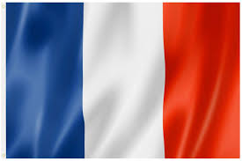

Overview of Units of Work for French
Year Group | Autumn 1 | Autumn 2 | Spring 1 | Spring 2 | Summer 1 | Summer 2
Yr 3 | Core 1 | Core 2 | Core 3 | Animals | Food | At School
Yr 4 | Playtime | My Home | My Town | Describing People | The Body | Sport
Yr 5 | On Holiday | Eating Out | Hobbies | School Trip | Seasons | The Environment
Yr 6 | Actions | In France | Family | A Weekend with Friends | The Future | Jobs

