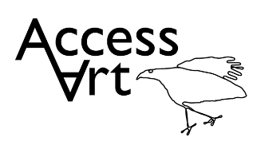
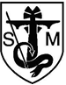
St. Michael’s CE Primary School
Art Curriculum Plan
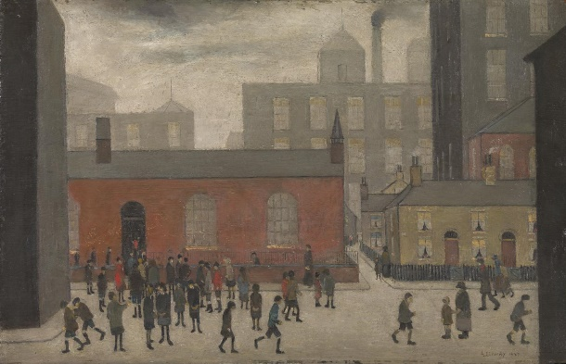

Coming Out of School
L.S. Lowry (1927)

Curriculum Intent
At St. Michael’s, we strive to provide our children with a broad and balanced curriculum in order to allow each and every child to leave our school as a well-rounded learner, ready to embrace the next steps in their education. We value art as an integral part of our curriculum offer. Through the use of the AccessArt Split Curriculum scheme, teaching of art at St. Michael’s engages, inspires and challenges our children and provides them with the opportunity to develop both their skills in a range of media and their knowledge of art, including the impact that artists have had throughout history and in contemporary life. By the time they leave St. Michael’s, we hope that every child has been challenged to express their individual interests, thoughts and ideas through their own art work; inspired by the artists that they have studied and drawing on the knowledge and skills that they have developed. The AccessArt Split Curriculum was selected to run concurrently with the Design Technology scheme – with each year group completing three units of work from each subject.
We use the AccessArt Split Curriculum scheme. It has been created from the National Curriculum (2014), ensuring that all pupils:
- produce creative work, exploring their ideas and recording their experiences

- become proficient in drawing, painting, sculpture and other art, craft and design techniques

- evaluate and analyse creative works using the language of art, craft and design

- know about great artists, craft makers and designers, and understand the historical and cultural development of their art forms
Curriculum Implementation – EYFS
In the Early Years and Foundation Stage, children are given daily opportunities to develop their art skills within the continuous provision and targeted activities provided as they work towards the Early Learning Goal for Expressive Arts and Design. At St. Michael’s, we have developed our own ‘EYFS Art Curriculum’ based on the key skills and experiences that we believe our children need in order to achieve that Early Learning Goal and be ready for the art curriculum in Year 1. These skills and experiences are underpinned by the statements provided within the ‘Development Matters’ document for ‘3 and 4 year olds’ and ‘Children in Reception’.
Curriculum Implementation – Year 1 to Year 6
Each year group in school (Year 1 – Year 6) completes three units of work in art throughout the year. The AccessArt scheme is devised so that each term (Autumn, Spring and Summer) there is a thread running through the work in each year group. Autumn term units focus on ‘Sketchbooks and Drawing’, Spring term units focus on ‘Surface and Colour’ and Summer term units focus on ‘Working in Three Dimensions’. The units covered by each year group have been selected so that our art curriculum covers the widest range of opportunities, styles, media and artists possible. They are as follows:
 | Year 1 | Year 2 | Year 3 | Year 4 | Year 5 | Year 6
Autumn Term | Spirals | Explore and Draw | Gestural Drawing with Charcoal | Storytelling through Drawing | Typography and Maps | 2D Drawing to 3D Making
Spring Term | Simple Printmaking | Expressive Painting | Paint, Cloth, Thread | Exploring Still Life | Fashion | Exploring Identity
Summer Term | Making Birds | Be an Architect | Telling Stories through Drawing and Making | The Art of Display | Set Design | Take a Seat

When teaching a unit of art, teachers use all aspects of the AccessArt Split Curriculum to support the curriculum that they offer in their classroom, including:
- Medium Term Plan
- Progression of Vocabulary
- Progression of Knowledge and Skills
- Pathway (including links, videos, photographs, questions and examples)
At St. Michael’s, we use sketchbooks (from Year 1 to Year 6) in art lessons. Sketchbooks enable our children to see their own progress throughout each unit of art, as well as their progress throughout each year, and to develop their own artistic style when presenting their work. The use of sketchbooks also allows for our children to develop their abilities to critically analyse art work and to annotate both their own work and the work of professional artists with increasing confidence, understanding and sophistication. Our teachers have their own sketchbooks in order to demonstrate skills during lessons as the ‘expert in the room’ and to further cultivate the belief that ‘everyone is an artist’.
Curriculum Impact
For our art curriculum to have had a positive impact, we believe that children should have developed their knowledge in art, their skills in art, their abilities to reflect on artwork and have developed an enjoyment of art.
We assess the attainment and achievement of our children in art based on their work throughout the unit, as well as the final piece of artwork that they produce. During and after each lesson, teachers assess work and progress made using our whole school procedure for lesson marking. By the end of each unit of art, teachers assess each child’s work against the AccessArt knowledge and skills statements for that unit so that achievement in both aspects of the art curriculum are celebrated and recorded. Teachers use the school assessment system (Ontrak) to record their assessments for each child.
The impact of art teaching and the art curriculum that we offer at St. Michael’s is monitored by the Art Subject Lead, with support from the Linked Curriculum Team. Monitoring of art is carried out by:
- looking at children’s work in sketchbooks
- comparing the work in sketchbooks to the AccessArt planning
- carrying out pupil voice to gather children’s views
- holding a termly Art and DT Showcase – to enable children, parents and staff to walk through a whole school gallery of work in the two subjects to see progress and outcomes, while providing an appreciative audience for the children’s work.

